SERVICE DESCRIPTION: Optus Unified Endpoint Management Services

This Service Description forms part of the Optus General Terms and Standard Form of Agreement pursuant to the Telecommunications Legislation.

This Service Description for Unified Endpoint Management comprises the following Parts:

- Part 1: Service Family Terms (applicable to all Optus Unified Endpoint Management Services); and

- Part 2: Service Option Terms.

The Service Option Terms are separate terms applicable to each of the following Service Options and are to be read in conjunction with both the General Terms and the Service Family Terms:

- Optus Unified Endpoint Management (UEM) powered by MobileIron

- IBM MaaS360

SERVICE FAMILY TERMS: Optus Unified Endpoint Management Services
If there is any inconsistency between the terms of the documents that form the Agreement, they will be interpreted in the following order of precedence: the Standard Pricing Table, the Service Option Terms of the Service Description, the Service Family Terms of the Service Description, the General Terms and the Application, except to the extent of any inconsistency in pricing (in which case the Application overrides the Standard Pricing Table).

- SERVICE FAMILY

  - Service Description

The Optus Unified Endpoint Management Services allow your organisation to manage its mobile and other devices. The Services can include on-premises or cloud-based platforms to manage devices and client software that is installed on each device to enable such management.

  - Optus Group Company

The Optus Unified Endpoint Management Services are supplied by Optus Networks Pty Ltd (ABN 92 008 570 330).
  - Separate supply of mobile devices and digital services

The supply of mobile devices and plans is not covered by this Service Description and you will need to purchase these separately.

- SERVICE OPTIONS

  - Service Options
- Optus Unified Endpoint Management Service (UEM) powered by MobileIron
- IBM MaaS360

each a “Service”.

  - Selecting Service Options

Some Service Options can only be provided to you on the basis that you also acquire other Service Options. Service Options which are prerequisites to other Service Options are noted in the Service Option Terms as ‘Related Service Options’. Information on prerequisite Service Options is contained in the Application or as advised by Optus when you lodge the Application.

- CANCELLATION FEE

  - Where your Service or Individual Service is cancelled during the Committed Term and a Cancellation Fee is payable under the General Terms, Standard Pricing Table or your Application, you will need to pay us an amount equal to the net present value of:
  - the profit component of all amounts that would have been payable in respect of the monthly recurring charge for the relevant Individual Service for the remainder of the Committed Term from the date cancellation takes effect; plus
  - all amounts that will be incurred by Optus as a result of the cancellation; plus
  - any unavoidable third party costs that will be incurred by Optus, in respect of the relevant Individual Service for the remainder of the Committed Term from the date cancellation takes effect;

unless a different formula or a specified amount is otherwise expressly provided in the Standard Pricing Table or your Application.

- SUPPLY, USAGE AND FUNCTIONALITY
  - Service Provision
  - Your Application will contain your selected Service Option(s), a Target Service Start Date (where applicable), the charges and any applicable features and characteristics.
  - The Service Start Date for Optus Unified Endpoint Management Service is deemed to occur on the earlier of:
      - the date the Optus Unified Endpoint Management Service has been activated in the cloud or the Management Platform has been installed on your infrastructure (for on-premises options); and
      - 60 days after you have signed your Application.

- FAULT REPORTING
  - As soon as you become aware of any Fault in the Service, you must report that Fault to Optus by telephoning the number in the applicable Service Option or as otherwise notified to you by Optus from time to time.

- OPTUS’ RIGHTS, OBLIGATIONS AND REQUIREMENTS
  - Optus is not responsible for your usage or configuration settings, or the outcomes or use of the functionality you configure within the Service.
  - Optus may:
    - monitor the number of licences activated which will be automated once the Management Platform has been installed. The Management Platform communicates to the Application Gateway and reports on the number of licences. This information is required for billing purposes;
    - monitor the usage of the Service in the applicable Management Platform to ensure compliance with the Agreement;
    - investigate any misuse of the Service and may involve police or other law enforcement agencies in doing so; and
    - recover from you any costs of investigating misuse if we have found that you or your Personnel or End Users have misused the Service (including preventing Optus from obtaining licence information). If such misuse causes loss to another user and Optus is required to pay compensation to that user, Optus may require you to reimburse Optus.
  - Optus will not provide customer service for the connection of additional hardware, networking devices or local area network (LAN) to the Service unless expressly provided for in your Application(s).
  - You acknowledge that:
    - Optus may be required to keep records of and provide details to the Third Party Service Provider relating to your use of the relevant software and services and you authorise Optus to do so;
    - Optus, acting in its capacity as an agent for the Third Party Service Provider, will invoice you for the third party Products and services. You appoint Optus as your agent for ordering and making payment to the Third Party Service Provider on your behalf;
    - Optus may cancel your right to use the third party Products or services by notice to you where the Third Party Service Provider ceases to supply the third party Product or service for any reason. On the date of effect of cancellation, you will be entitled to a proportionate refund of any relevant prepaid service charges applicable to the supply of the relevant third party Products or services. To the extent permitted by law this will be your sole and exclusive remedy for such cancellation;
    - your use of the third party Products and services will involve the collection and processing of data and information, which may include personal information. You, Optus and the Third Party Service Provider are severally responsible for compliance with the relevant laws relating to privacy. Optus and the Third Party Service Provider will manage such data in accordance with their respective policies and procedures;
    - Liability for your Loss in connection with Products or services from a Third Party Service Provider which are on-supplied by Optus, whether in contract, tort (including negligence), statute, under an indemnity or otherwise, is excluded by Optus to the extent permitted by law, and is governed by the Third Party Usage Terms between you and the Third Party Service Provider;
    - To the extent permitted by law, if Optus is liable to you in connection with Products or services from a Third Party Service Provider, whether in contract, tort (including negligence), statute, under an indemnity or otherwise, Optus excludes liability for Consequential Loss and limits its liability to the price you have paid for the relevant third party Products or services;
    - Where you use third party Products and services that are not on-supplied to you by Optus, you are responsible for ensuring you obtain all necessary approvals and licences to authorise your use of those Products and services in conjunction with the Service.

- YOUR RIGHTS, OBLIGATIONS AND REQUIREMENTS
  - Optus may provide you with a technical questionnaire which you must complete and return so that Optus can check that your equipment or environment meets the Minimum System and Network Connectivity Requirements. If your equipment or environment does not meet the Minimum System and Network Connectivity Requirements, the applicable software installation will either be significantly delayed or not installed at all.
  - In using the Service you must:
    - ensure that any software you may use with the Service is properly licensed; and
    - comply with any rules imposed by any third party whose Content or services you access using the Service or whose network your data traverses.
  - You acknowledge that:
    - You take full responsibility for all actions taken whilst using the Service. It is your responsibility to determine and implement your own device policies, including without limitation those relating to security, updates and configuration. You must comply with all applicable privacy legislation and ensure that you inform your End Users about your device policies and what you will and will not restrict when the application is installed on an End User’s device. For example, if you restrict access to certain applications, such as Facebook, you take responsibility for notifying your End Users to ensure they are aware of this.
    - Optus will not be liable for any loss of data or damage resulting from any actions taken whilst using the Service. For example, if a device is stolen and you decide to remotely wipe particular applications or the entire device itself of all its content, you take full responsibility for this decision and resulting action.
    - If you intend to develop in-house applications for distribution you are required to have respective developer accounts for each relevant platform (for example, Apple Developer Account, Android Developer Account).
    - The Service relies for its operation on services supplied by third parties who are not controlled or authorised by Optus and, in these cases, Optus is not responsible or liable for the acts and omissions of such third parties.
    - Optus is an authorised reseller of these products and will provide you access to the latest Updates or fixes to the software when made available by the relevant Third Party Service Provider. Optus will not be held accountable or responsible if there is no Update or fix available, however, will assist in requesting this from the Third Party Service Provider.
    - If the Service is cancelled or terminated, you must cease using the Service, unenroll and de-register all End Users and delete the software from your appliances and devices.
    - System Administrators must be aware that, when adding or changing software licences within the Management Platform, that they must first select to "retire" a licence before changing or updating to a new End User or Device, otherwise this will increase the total organisation’s licence count (which cannot be reduced).
- SPECIAL CONDITIONS
  - You must not use the Service to run or provide network services to any third parties.
  - Within 60 days after the date the Agreement is signed, you are obliged to allow Optus to commence the supply of the Service. If you fail to meet this obligation, Optus reserves the right to bill you for the total number of licences you have selected, as set out in the Application, regardless of whether Optus has commenced supply or you have activated the total number of licences.
  - You must enter into an End User Licence Agreement (EULA) which must be read and accepted by you to enable you to use the Service, during the installation process. Your use of any third party Products and services (including intellectual property) is conditional upon your acceptance and compliance with the relevant EULA. The EULA may be amended from time to time. If you do not accept the amended EULA, you must cancel the Service. If you do not comply with, or respond to a request from Optus or the Third Party Service Provider to accept or comply with, the EULA, Optus may cancel your right to use the third party Products or services. The EULAs may be found at:

Optus UEM:

https://info.mobileiron.com/EULAClickTHrough_EULARegistrationPage.html.
IBM MaaS360:
https://www.ibm.com/software/sla/sladb.nsf/sla/sd-6741-07

- DEFINITIONS

Terms not defined in these Service Family Terms are as defined in the General Terms or the applicable Service Option, unless inconsistent with the context.
Application Gateway is the secure point where the information for the number of licences is communicated through for billing purposes.
Minimum System and Network Connectivity Requirements has the applicable meaning in each Service Option;
Related Service Option means those Service Options that are pre-requisites to obtaining the relevant Service;
Service Description means the Service Family Terms and Service Option Terms applicable to the Optus Unified Endpoint Management Services.
Service Feature means an associated service which will incur a specific charge, and which must be selected by you in your Application. The availability of a Service Feature is dependent on the Service Option you select and the relevant Service Option Terms
Service Family Terms mean these terms applicable to all Service Options set out in Part 1 of this Service Description.
Service Options means the service options detailed at the beginning of this Service Description.
Service Option Terms mean the terms applicable to each Service Option set out in Part 2 of this Service Description.
Target Service Start Date means the date, if any, requested by you and/or estimated by Optus and agreed between the parties, as the target date on which the Service is intended to be activated and supplied to you, as specified in the Application or as otherwise agreed with you in writing during the kick off meeting.
Third Party Service Provider means the third party service provider identified in the relevant Service Option Terms.
Third Party Usage Terms means any warranty terms, end user licence agreement, software, or support terms of the Third Party Service Provider.
Updates shall mean any updates, upgrades, maintenance releases, bug fixes or modified versions of the software provided to the customer.

SERVICE OPTION TERMS
Service Option: Optus Unified Endpoint Management (UEM) powered by MobileIron
This Service Option forms part of the Optus Unified Endpoint Management Services.
The Service Description for the Optus Unified Endpoint Management Services comprises the following Parts:
- Part 1: Service Family Terms (applicable to all Optus Unified Endpoint Management Services); and

- Part 2: The Service Option Terms.

The Service Option Terms are separate terms applicable to each of the Service Options and are to be read in conjunction with both the General Terms and the Service Family Terms:

- DESCRIPTION OF THE SERVICE OPTION
  - Service Option Description
    - The Optus Unified Endpoint Management (UEM) Service powered by MobileIron is a service used by organisations to secure and manage business applications, documents and other business content on mobile phones, tablets and Apple Mac devices, including both corporate and user owned (BYOD) devices.
    - This Service includes a Management Platform for System Administrators and a light-weight client (Client Application Software) that resides on the End User’s device.
    - Once a device is enrolled, System Administrators use the Management Platform to enable their End Users by setting security and management rules to allow access to email, applications and services. It also ensures the device is secured in accordance with your policies.
    - The Client Application Software provides your IT department with information about the device and its security state.
    - This information includes things like carrier, country, device make and model, operating system (OS) version, phone number, and other attributes. While it does report business related data, it does not give IT visibility into any personal information to provide privacy to its End Users.
  - Optus Group Company

The Optus Unified Endpoint Management (UEM) Service is supplied by Optus Networks Pty Limited (ABN 92 008 570 330), an Optus Group Company.
  - Third Party Software

The Optus UEM Service includes the reselling or on-supply of third party software as part of this Service. The Third Party Service Provider is MobileIron, Inc. (a Delaware corporation having a place of business at 401 East Middlefield Road, Mountain View, CA 94043).

- SUPPLY, USAGE AND FUNCTIONALITY
  - The Optus UEM Service can be provided as a cloud or on-premise solution. For an on-premise solution, you are required to ensure that your own equipment or environment meets the Minimum System and Network Requirements prior to the installation of the Optus UEM software being completed. It is your responsibility to ensure your equipment or environment is ready when you sign the Agreement or your installation will be delayed or not installed at all.
  - The Optus UEM Service consists of:
    - Management Platform – Allows you to view, manage and secure devices from a single portal. The Management Platform consists of one mandatory component of either Cloud or Core (and other optional components) that operate as either physical or virtual appliances:

Mandatory:
      - MobileIron Cloud (“Cloud”) is the centralised administrative web portal from which all profiles and policies are managed. The portal also hosts a database of all devices registered.

OR

MobileIron Core (“Core”) is the on-premise centralised administrative web portal. Core manages all profiles and policies, as well as keeping a database of all devices registered. Core is an all-in-one platform, utilising Linux (CentOS 7) which removes the need for any additional host server or data base licences for standard deployments.
      - Connector (optional) - Provides the ability for the Management Platform to securely sync additional corporate resources, such as an on-premise LDAP server or a Certificate Authority (CA). Some customers may use the Connector to secure inter-DMZ LDAP traffic even when the Core is on-premise. Connector may be deployed as a physical hardware appliance or as a virtual appliance. Note: For On-Premise Core customers who ONLY need to synchronise an LDAP Server and not a CA, Connector is not required.
      - Sentry (optional) – Sentry is an in-line Proxy gateway that manages, encrypts, and secures traffic between the device and back-end Services, such as email, internal intranet or other applications. Sentry can also block access to corporate resources based on Certificates, policy violations, its current security posture or if the device is enrolled into the Management Platform or not. Sentry may be deployed as a physical hardware appliance or as a virtual appliance.
      - Client Application Software (MobileIron Client) – Once a device is registered, the Client installs configuration, apps, and other content from the Management Platform. It also deploys and enforces security policies designed by the organisations System Administrator(s).
    - Installation, setup and maintenance of the Management Platform - If you choose to purchase a Deployment Package, Optus will organise installation and configuration of the Management Platform. Depending on the deployment package purchased, the System Administrator will also be provided with a certain number of training hours and a final handover of the Management Platform.
    - Help Desk – If you have opted for MobileIron Direct Support (Premium Support) Service, your System Administrator(s) can call the MobileIron Premium Customers phone line 24 hours a day, 7 days a week on (02) 8038 5002. You will also have access to log support tickets via the Community Portal and be provided direct details of your local Account Manager for any other enquiries.

If you purchased Optus UEM prior to December 2018, your System Administrator(s) may continue to utilise and gain technical support for the Management Platform through Optus’ help desk during Australian Eastern Standard time (AEST) business hours of 8am-6pm weekdays (excluding public holidays) by phoning: 134 315. Technical support is only for Optus UEM fault related enquiries or issues that cannot be answered or solved by your System Administrator by utilising the administration guide which is both provided during training and can be accessed at any time within the Management Platform. You should be aware that in order to troubleshoot during support, Optus may require remote access to your servers.
  - Management Platform functionality

Table 1 below identifies the Service Feature inclusions for each of the licence types that are available to purchase (Silver, Gold and Platinum). This is current as at the date of this Service Description below. The available functions may change over time and an updated list of available functions can be accessed at www.mobileiron.com. Some features and functionality may not be available on some Mobile Devices (see Supported Mobile Device, Operating Systems & Account Requirements at www.mobileiron.com)

Table 1: Service Features
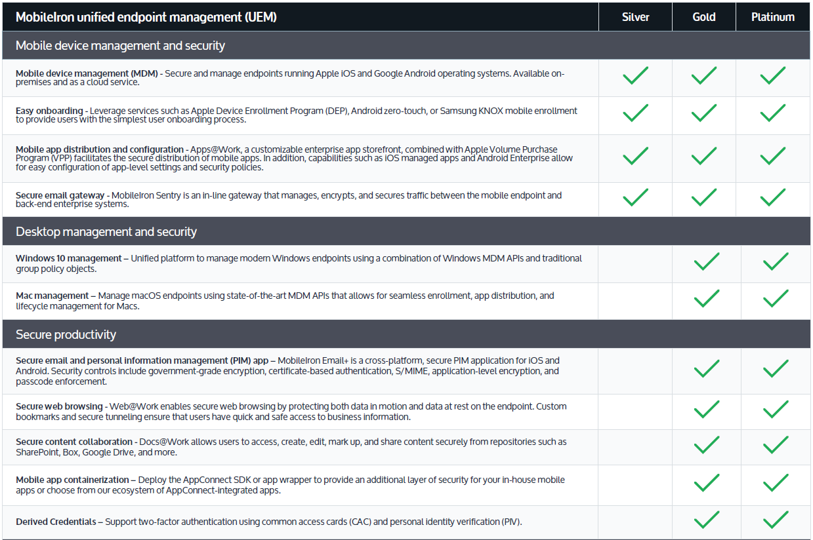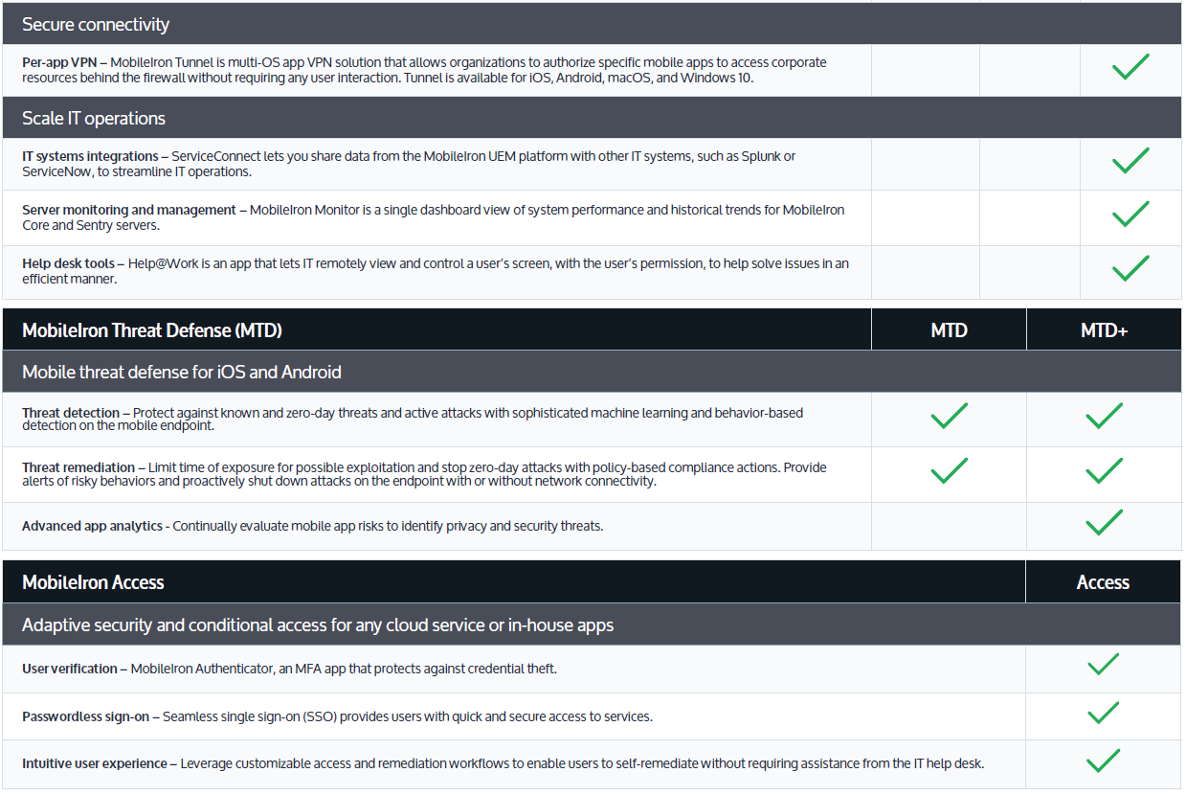

*If you are upgrading from Silver to Gold, Platinum, or adding Mobile Threat Defence (MTD) or MobileIron Access you may require further Professional Services hours to assist in the deployment of these services.

- MINIMUM SYSTEM AND NETWORK CONNECTIVITY REQUIREMENTS

The minimum technical requirements for setup of your equipment or environment are based on the Service Feature chosen above (that is Silver, Gold or Platinum). These requirements will be provided to you during your kick off meeting.
  - Minimum Requirement for the Management Platform:
    - If you have chosen an on-premise deployment, the Management Platform must be installed on a computing appliance conforming to the Minimum System and Network Connectivity Requirement. If your equipment or environment does not meet the Minimum System and Network Connectivity Requirement at the time of installation, the software installation will either be significantly delayed or unable to be installed at all.
    - If you have chosen an on-premise deployment, the installation of the Management Platform will be provided by an authorised Optus technician remotely via Internet access. You are responsible to ensure that remote Internet access is available and working to enable the Optus technician to install the software, otherwise you will not be able to successfully use the Service.
    - Optus will set up the Management Platform so that it is ready for use and will then hand over the operation of the system to your System Administrator. Your System Administrator is responsible for determining and configuring the functionality requirements from the relevant available functions (refer (see section 2.3 - Management Platform functionality above).
  - Minimum Requirement for the Client Application Software:
    - The Client Application Software must be installed on Supported Mobile Devices. If a device is not supported, it will not be able to use the Service.
    - The installation of the Client Application Software is initiated differently depending on the device ownership, either user-owned (BYOD) or corporate-purchased:
      - User Owned (BYOD) – An End User can register via the enrolment URL in their Device browser, or by directly downloading the MobileIron application from their Device’s app store. If the End User opts for the URL method, they can manually navigate to the URL or have it sent to them by either email or SMS. Across all methods, the enrolment process is guided and includes user instructions.
      - Enterprise-Issued – The Client Application Software installation and enrolment process can be automated for any Supported Mobile Device out-of-the box, across all operating systems (iOS, Android, macOS and W10). The End User will either turn on the new device and be auto-prompted for either identification or credentials and, once entered, the device will auto-install and enrol into the Management Platform. If the devices are not new, they can be factory reset to auto-enrol into the Management Platform. If the device does not support the auto-enrolment methods, it can be enrolled via a QR Code, NFC Bump or enrolment hashtag (#) on setup or reset.
    - To install the Client Application Software, the Device needs to have either a mobile network or Wi-Fi internet access to the Management Platform. It must also conform to the individual user account requirements.
    - Policy updates are pushed out via the Internet to registered Supported Mobile Devices. Supported Mobile Devices therefore will consume mobile data or wireless internet usage, which will be at the Device owner’s own cost. Before the installation of the Client Application Software, your End Users should perform a backup of the important files on their device.

- SERVICE CHARGES
  - Subscription or Perpetual Licence Service
    - The Optus UEM Service can be sold on a Subscription or Perpetual model and both are based on the number Client Application Software licences specified during your initial purchase agreement with Optus. This is independent of the number or type of Optus mobile voice and data services.
    - Perpetual Licences require an annual support fee to be purchased for the number of active licences. If this is not renewed on or before the current contract expires, there may be a reinstatement fee imposed by the Third Party Service Provider.
  - Minimum Licences
    - You may add additional licences in the Management Platform at any time within the term of your Agreement. The charge on your Optus bill per month or per annum will be determined by the greater of:
      - the number of licences agreed in your Application; and
      - the highest number of licences configured on your Management Platform at any one time during the term of your Agreement, notwithstanding a subsequent reduction in the number of licences.
  - If you have purchased an annual Subscription licence and increase your active licence count during the term, you will be charged a minimum block of 25 additional licences. This will be calculated as a pro-rated amount depending on the number of months left in the year. For example, if you purchase 100 per device licences for $50.00 ex GST each in January and your active licence count shows as 106 licences in March, you will be charged for 25 new licences at $50 x 10/12 months = $1041.67 ex GST.
  - Additional Services (including professional services) may be added at any time during the term of your Agreement. These services will incur an additional charge and will appear as separate line items on the Optus bill.

- 30-Day Evaluation
  - You may elect to participate in a 30-day evaluation of the Service (“Evaluation”). The Evaluation will commence on the Service Start Date and continue for 30 calendar days (“Evaluation Period”) and your Committed Term will automatically be extended by 1 month. For example if you sign up for a 24 month Committed Term and you also select the Evaluation, your Committed Term will be 25 months.
  - You will be liable for the set up and installation charges when you elect to participate in a 30 day trial Evaluation, even where you elect to cancel prior to the end of the 30 calendar days, however you will not be charged a licence fee during this period.
  - Prior to commencing your Evaluation, Optus will ask you to review (and confirm in writing to your Optus Account Manager) your internal objectives and requirements for the Service and agree to a maximum of 5 MobileIron functions that will be implemented, tested and measured throughout the Evaluation Period. Upon completion of the Evaluation, you may request that Optus waive, but Optus is not obligated to waive, the set up and installation charges if you believe that these functions did not meet your internal objectives. Any waiver of the set up and installation charges will be at Optus’ sole discretion.

- DEFINITIONS
Terms not defined in these Service Option Terms are as defined in the Service Family Terms or the General Terms (in that order) unless inconsistent with the context.
Client Application Software means the software defined in clause 2.2(a)(iv) of this Service Option Description.
Device Policy is the set of rules and settings for your End Users that you manually configure on the Management Platform in line with your information security requirements.
End User Licence Agreement means the licence agreement between MobileIron Inc. and the End User which lays out certain terms that must be adhered to. The Systems Administrator will be required to sign (both physically and electronically), an End User Licence Agreement (EULA) for the MobileIron Core server platform.
Linux (CentOS 7) is an open-source operating system distribution, based off Linux. MobileIron use CentOS as the fundamental framework for the MobileIron Core Platform. MobileIron Core currently use a modified version of the Cent OS 7 Distribution.
Management Platform means the software defined in clause 2.2(a)(i) of this Service Option Description.
MobileIron Cloud is a key component of the MobileIron Platform. It is the administrative console through which administrators can define security and management policies for devices, apps, and Services. Cloud also integrates with enterprise IT systems such as LDAP directories, email, content repositories, network access control systems, SIEMs and other third party software. MobileIron Cloud is securely hosted on Soc 2 Type 2 and ISO 27001 Verified Servers locally in Sydney, Australia.
MobileIron Core (Core) is a key component of MobileIron On-Premise Deployments. It is the administrative console through which administrators can define security and management policies for devices, apps, and Services. Cloud also integrates with enterprise IT systems such as LDAP directories, email, content repositories, network access control systems, SIEMs and other 3rd party software. Core may be deployed as a physical hardware appliance or as a virtual appliance using VMware ESX, Microsoft Hyper-V or Verified open KVM software.
MobileIron Inc. is the owner of the software which Optus is authorised to resell.
Perpetual is where the software licences are purchased upfront on a perpetual basis (this requires an annual support fee to be purchased).
Subscription is where the software licences are granted from Optus for a minimum committed term.
Supported Mobile Devices are the mobile devices and operating systems that the software supports. See the MobileIron webpage for updated information: https://www.mobileiron.com/en/resources-library/faq
System Administrator is your chosen authorised contact or team of people within your organisation who will be trained on the usage and configuration of the software and who will maintain such software once trained by Optus.
URL (Uniform Resource Locator) is the unique address for a file that is accessible on the Internet.

Service Option: IBM MaaS360
This Service Option forms part of the Optus Unified Endpoint Management Services.
The Service Description for the Optus Unified Endpoint Management Services comprises the following Parts:
- Part 1: Service Family Terms (applicable to all Optus Unified Endpoint Management Services); and

- Part 2: The Service Option Terms.

The Service Option Terms are separate terms applicable to each of the Service Options and are to be read in conjunction with both the General Terms and the Service Family Terms:

- DESCRIPTION OF THE SERVICE OPTION
  - Service Option Description

IBM MaaS360 is a cloud-based SaaS product offered by IBM that allows for the management of BYOD and enterprise-issued devices, including smartphones, tablets and laptops.
  - Optus Group Company

IBM MaaS360 is supplied by Optus Networks Pty Limited (ABN 92 008 570 330), an Optus Group Company.
  - Third Party Software

This product includes the on-supply of third party software as part of this Service. The Third Party Service Provider is IBM, located at Level 13, IBM Centre, 601 Pacific Highway, St Leonards NSW 2065.

- SUPPLY, USAGE AND FUNCTIONALITY
  - IBM MaaS360 is provided as a cloud solution which is located in both New York and Dallas USA.
  - IBM MaaS360 consists of:
    - Client Application Software – Unified Endpoint Management software that is installed and runs on Supported Mobile Devices to implement the policies you have set in the Management Platform.
    - Management Platform

(i) Optus will arrange installation and configuration of the software which is carried out over 1 day (8 hours) of work.

(ii) This service is provided free of charge if you purchase 300 or more licences.

(iii) If there is a requirement to travel outside metropolitan areas there will be additional charges.

(iv) If more than 1 day (8 hours) of work is required to install IBM MaaS360 into your environment due to changes in scope or delays caused by you, then any additional time for installation will be charged at the applicable technical engineer per day rate.

(v) Depending on your requirements (see clause 3 Minimum System and Network Connectivity Requirements below), Optus will configure one or more of the items below during deployment:

(A) MaaS360 Cloud Extender for User Visibility and User Authentication - if you do not have an on-premises Active Directory (AD), there will be a requirement to install a Cloud Extender on-premise to enable your email. For cloud-based Active Directories like Microsoft Azure AD, Optus requires the Customer’s Microsoft Azure AD Tenant ID only for the integration.

(B) Integration with Microsoft Exchange for secure email and real time notifications.

(C) Certificate Integration Module for access to corporate resources such as Microsoft Exchange.

(E) MaaS360 Mobile Enterprise Gateway for mobilisation of enterprise content such as file repositories and intranet data.
    - Help Desk – your System Administrator(s) can obtain technical support for the Management Platform through Optus’ help desk Monday to Friday from 8am - 5:30pm Australian Eastern Standard Time (AEST) excluding National Public Holidays by:

(i) phoning: 1300 300 242

(ii) emailing: support@prompto.com.au or

(iii) logging a ticket on the web portal: www.support.prompto.com.au.

Technical support is only for IBM MaaS360 fault-related enquiries or issues that cannot be answered or solved by your System Administrator by utilising the administration guide which is provided during training. You should be aware that, in order to troubleshoot during support, Optus may require remote access to your servers.
  - Management Platform functionality

Table 1 below identifies the Service Feature inclusions for each of the licence types that are available to purchase (Essentials, Deluxe, Premier or Enterprise). This is current as at the date of this Service Description set out below. The available functions may change over time and an updated list of available functions can be accessed at www.ibm.com. Some features and functionality may not be available on some mobile devices (see Supported Mobile Device & Account Requirements at https://www.ibm.com/support/knowledgecenter/en/SS8H2S/com.ibm.mc.doc/pag_source/concepts/devices_supported_sps_UEM.htm ).

Table 1: Service Features
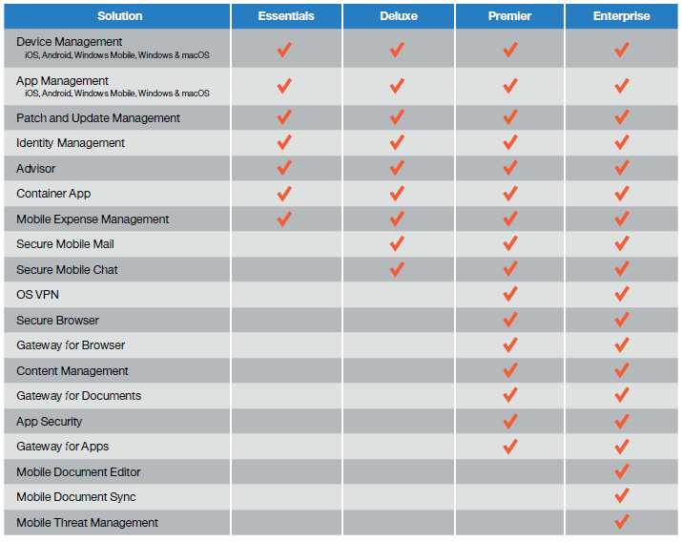

- MINIMUM SYSTEM AND NETWORK CONNECTIVITY REQUIREMENTS

The minimum system requirements for setup of your environment are based on the Service Feature chosen above (that is, Essentials, Deluxe, Premier or Enterprise). A pre-requisite task document will be provided to you during your kick off meeting which entails all pre-installation requirements and tasks to be completed by you. You may also request this prior to the contract being signed to ensure you are compliant with these requirements to ensure no delay in installation.
  - Minimum Requirement for the Management Platform:
    - If your computing environment does not meet the Minimum System and Network Connectivity Requirement at the time of deployment, the deployment will either be significantly delayed or may not be deployed at all.
    - The deployment of the Management Platform will be provided by an authorised Optus technician remotely. You are responsible to ensure that Internet access is available and working to enable you access to the Service, otherwise you will not be able to successfully use the Service.
    - Optus will set up the Management Platform so that it is ready for use and will then hand over the operation of the system to your System Administrator. Your System Administrator is responsible for determining and configuring the functionality requirements from the relevant available functions (see 2.3 Management Platform functionality above).
  - Minimum Requirement for the Client Application Software:
    - The Client Application Software must be installed on a Supported Mobile Device. If your mobile device is not supported, it will not be able to use the Service.
    - To install the Client Application Software, your mobile Device needs to have mobile network or Wi-Fi internet access to the Management Platform and conform to the individual user account requirements depending on the Supported Mobile Device.
    - Policy updates are pushed out via the Internet to registered devices. Supported Mobile Devices therefore will consume mobile data or wireless internet usage as part of these downloads, which will be at the Device owner’s cost. Before the installation of the IBM MaaS360 Client Application Software, your End Users should perform a backup of the important files on their device.

- SERVICE CHARGES
  - Subscription Licence Service

The IBM MaaS360 Service is sold as a Subscription model and is based on the number Client Application Software licences specified at your initial Agreement with Optus. This is independent of the number or type of Optus mobile voice and data services.
  - Minimum Licences

You may configure additional licences in the Management Platform at any time within the term of your Agreement The monthly charge on your Optus bill will be determined by either the greater of:
    - the number of licences agreed in your Application; and
    - the highest number of licences configured on your Management Platform at any one time during the term of your Agreement, notwithstanding a subsequent reduction in the number of licences.
  - Additional Services may be added at any time during the term of your Agreement. These Services will incur an additional charge and will appear as separate line items on the Optus bill.

- 30-Day Trial
  - You may elect to participate in a 30-day trial of the Service (“Trial”) from a cloud-based environment. The Trial will continue for 30 calendar days (“Trial Period”) once you have been provided with credentials to access the Trial. You need to request a Trial via this link: https://ob2.optus.com.au/MaaS360Trial

- DEFINITIONS
Terms not defined in these Service Option Terms are as defined in the Service Family Terms or the General Terms (in that order) unless inconsistent with the context.
Active Directory (AD) Active Directory serves as a central location for network administration and security. It is responsible for authenticating and authorising of all users and computers within a network of Windows domain type, assigning and enforcing security policies within to all computers in a network and installing or updating software on network computers.
Client Application Software means the software defined in clause 2.2(a) of this Service Option Description.
Cloud Extender is a lightweight agent that enhances device management capabilities by integrating with on-premises systems within your environment, such as email, corporate directories, certificate authorities, and application and content servers. The Cloud Extender requires minimum resources, can traverse proxy environments and provide secure messaging and data transfer between the MaaS360 platform and your on-premises systems.
Device Policy is the set of rules and settings for your End Users that you manually configure on the Management Platform in line with your information security requirements.
Management Platform means the software defined in clause 2.2(b) of this Service Option Description.
End User Licence Agreement means the licence agreement between IBM and the End User which sets out certain terms that must be adhered to. This will need to be agreed to at time of installation.
IBM Australia is the owner or licensor of the software which Optus is authorised to resell under this Service Option.
Subscription is where the software licences are granted from or procured by Optus for a minimum term.
Supported Mobile Devices are the mobile devices that the software supports. See the below IBM link for the most up to date information:
https://www.ibm.com/support/knowledgecenter/en/SS8H2S/com.ibm.mc.doc/pag_source/concepts/devices_supported_sps_UEM.htm
System Administrator is your chosen authorised contact or team of people within your organisation who will be trained on the usage and configuration of the software and who will maintain such software once trained by Optus.
URL (Uniform Resource Locator) is the unique address for a file that is accessible on the Internet.

